Brandon Hough

CPEN 3710

LQF316

Lab Exercise #4

**First Program (Fibonacci Series) Results:**

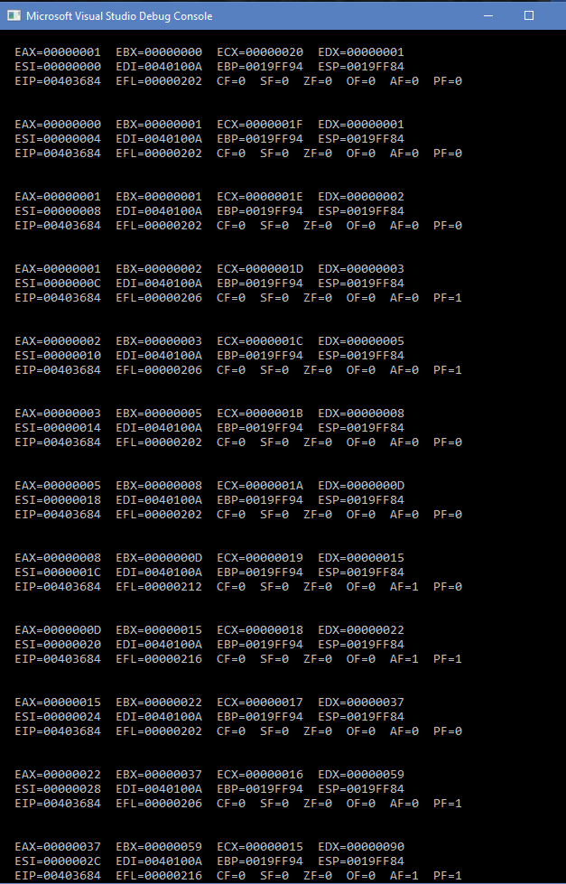

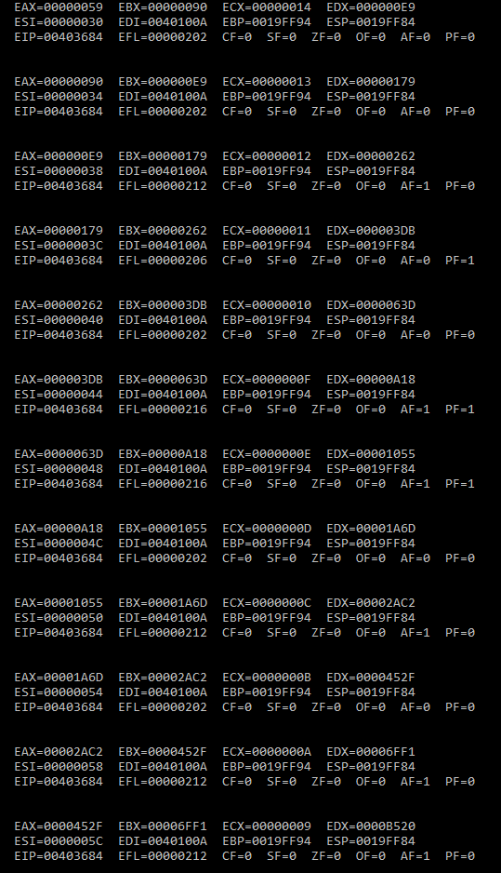

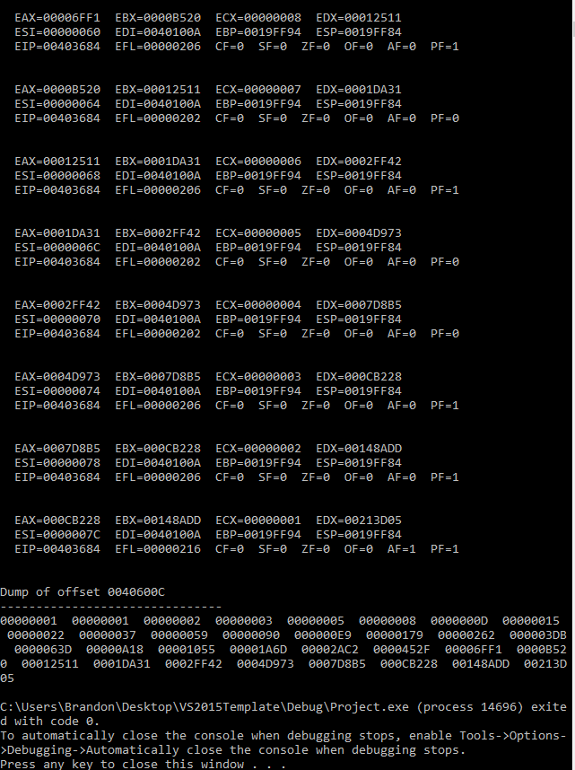

**Second Program (Reverse String) Results:**

